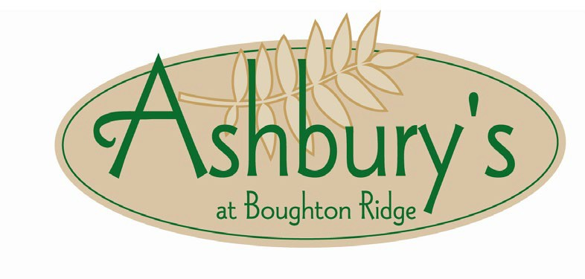

**Beverage and Bar Packages**

**Cash Bar:** Beverages are paid for by your guests when ordered

**Tab Bar:** Beverages are tracked throughout and paid at the conclusion of event; tax and Service Charge is added, and a pre-set maximum can be set.

Bartender Fee of $150 is added for all Cash and Tab Bars, and Wine Service in the Grand View Room; there is no bartender charge in the Dining Room. $200 minimum for Cash and Tab Bars in the Grand View Room.

**House Wine Service with Entrée:** $25.00 per bottle including tax and Service Charge, charged on consumption. Bartender Fee applies only for the Grand View Room.

**Open Bar:** host chooses duration of open bar and the service from below. Prices are per person and include tax and Service Charge. Minimum of 25 guests for Hosted Bar Packages.

*Prices are Per Person and include tax and Service Charge.*

|  |  |  |  |
| --- | --- | --- | --- |
| **Non-Alcoholic Beverage Service** |  | **Duration of Event** | |
| **Soft Drinks . . . . . . . . . . . . . . . . . . . . . . . . .** |  | **$5** |  |
| **Premium Non-Alcoholic Bar . . . . . . . . . . . . . . . .**  Fruit Punch, Juices, Mocktails, Soft Drinks |  | **$8** |  |
|  | **2 Hours** | **3 Hours** | **4 Hours** |
| **Alcoholic Beverage Service** |  |  |  |
| **Signature Cocktail, Mimosas & House Wine . . . . . . . .**  Includes soft drinks | **$22** | **$27** | **$30** |
| **Beer & House Wine . . . . . . . . . . . . . . . . . . . . .**  Domestic draft beer, soft drinks | **$22** | **$27** | **$30** |
| **Signature Open Bar . . . . . . . . . . . . . . . . . . . .**  House wine, well spirits, domestic draft and bottled beer, soft drinks | **$27** | **$30** | **$33** |
| **Platinum Open Bar . . . . . . . . . . . . . . . . . . . . .**  Premium wine and spirits, imported and craft beer, soft drinks, and a specialty cocktail | **$33** | **$36** | **$44** |
| **One-time Beverage Service** | **Any time during Event** | | |
| **Sparkling Wine Toast . . . . . . . . . . . . . . . . . . .**  Includes a non-alcoholic alternative |  | **$11** |  |

*Package details and menu prices are subject to change.*

*Subject to the Terms and Conditions of Ashbury’s at Boughton Ridge Golf Course. 11/24*