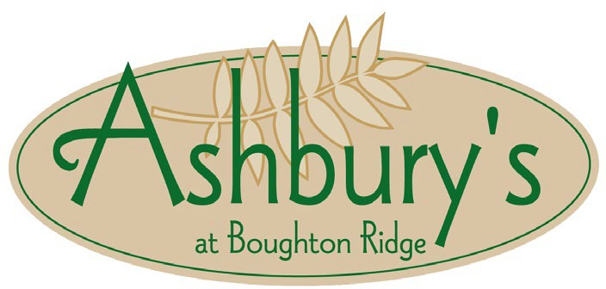

**Hors d’oeuvre Menu**

*Per Piece, Platter, & Dip Prices include tax and Service Charge.*

# Hors d'oeuvres & Canapés

$3 per piece, minimum 50 pieces per selection

## Jumbo Bar Wings

Teriyaki, Buffalo, or Honey BBQ

## Cocktail Meatballs

House marinara or BBQ

# Platters, Dips & Spreads

Serves 25 guests

## Crudité - $85

Fresh vegetables with buttermilk ranch

## Fresh Fruit - $92

Melon, Pineapple, Citrus, and Grapes

## Chicken Taquitos

Salsa & sour cream

## B.L.T. Bites

Lemon aioli in phyllo cups

## Spanakopita

Crispy spinach & feta

## Veggie Spring Rolls

Sweet chili dipping sauce

## Cheese & Crackers - $92

Cheddar, Swiss, and Pepper Jack with crackers and baguette Slices

## Chips & Salsa - $66 Bruschetta- $85

Marinated tomatoes, EVOO and fresh basil

## Spinach Artichoke Dip - $85

House made, crispy tortilla chips

*Subject to the Terms and Conditions of Ashbury’s at Boughton Ridge Golf Course. 11/24*