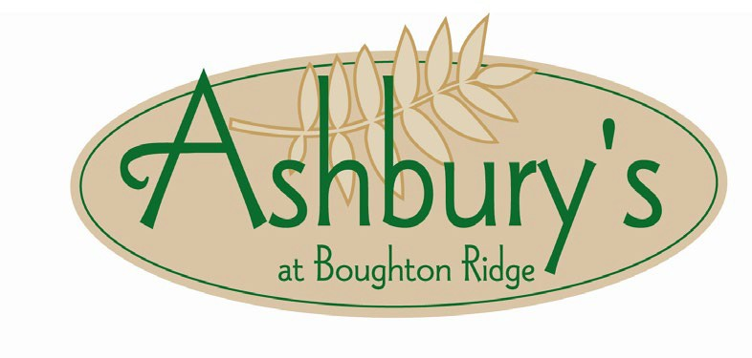

**Banquet Luncheon Menu**

Entrée Luncheons include Dessert, Rolls & Butter, Water, Coffee, & Hot Tea

Plated Luncheon: Choose a Starter and an Entrée - **$30**

Buffet Luncheon: Choose a Starter and two Entrées - **$35**

Deluxe Buffet Luncheon: Choose a Starter and three Entrées - **$44**

*Prices are Per Person and include tax and Service Charge - Lunch is served 11 am to 4 pm*

Tomato Basil Bisque Bruschetta

Crudité with Ranch Dip (buffet only)

Waldorf Salad

Broccoli Cheddar Soup

# Luncheon Starters

Vegetable Beef Barley Soup Caesar Salad

Windy City Chili, Sour Cream Dollop

Grilled Vegetables w/ Feta Cheese (buffet only)

**Upgraded Luncheon Starters – add $3**

House Salad

Fresh Fruit Cup

Pecan Blue Salad – (plated only)

# Luncheon Entrées – include Chef’s selection of a Fresh Vegetable

## Salisbury Steak, Brown Gravy

Served with Mashed Potatoes

## Vegan Medley

Bell Pepper with Santa Fe Blend & Roast Tomato Stuffed with Ancient Grains

## Beef Burgundy

Simmered in a red wine sauce with mushrooms and pearl onions. Served with Mashed Potatoes

## Chicken Cacciatore

Chicken Breast in a hearty tomato sauce with capers and green olives. Served with Bowtie Pasta

## Italian Sausage with Peppers and Onions

Marinara sauce, and served with Baked Ziti

## Roast Pork, Dijon Mustard Sauce

Served with Rosemary Roasted Red Potatoes

## Roast Breast of Turkey & Gravy

Served with Cornbread Dressing



**Upgraded Luncheon Entrées – add $6.50**

|  |  |
| --- | --- |
| **Grilled Salmon, Lemon Butter**  Served with Saffron Rice |  |

## Prime Rib

Carved 7 ounces, au Jus. Served with Oven Roasted Potatoes

**Special Value Luncheon Entrée – Plated Only - $27 - no Substitutions**

Choice of Soup, Breast of Chicken, Chef’s Selection of Starch and Fresh Vegetable, Cookies, Rolls & Butter, Unlimited Soft Drinks, Coffee & Tea.

Choice of one chicken preparation: Italian Seasoning with Marinara, Chimichurri, Sesame Soy Glaze, Alfredo Cream, or Lemon Caper

## Deli Platter Buffet - $32

Bread, Choice of Soup, Assorted Sliced Meats and Cheeses with all the Trimmings Served with Potato Salad, Cole Slaw, and Crudité

Fresh Baked Cookies

# Dessert

Cookies, Brownies, Lemon Bars, Cupcakes – served Family Style

Warm Apple Pie

Carrot Cake

**Upgraded Desserts – add $5**

NY Cheesecake

Triple Chocolate Cake

**Luncheon Sweet Table – add $8**

Includes above Dessert and choice of 2 Upgraded Desserts plus an additional Chef’s Sweet Surprise